*Design summary, change log and updates.*

This document is the chronological archive of the open bubble CPAP Design. It shows the working principle of the CPAP system

**Iteration 1:**

This is the first proposed design. It includes industrial grade as well as readily available off-the-shelf materials. 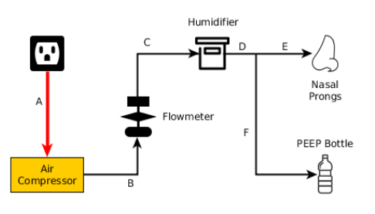

It consists of the basic fundamental parts of the system. I.e.

* Air compressor
* Flow meter
* Humidifier
* PEEP bottle
* Nasal prong

**Iteration 2:**

Tests, observations and changes:

* Air compressor, alternative enclosure and hardware selection.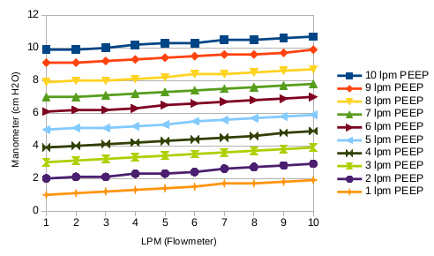
* Breathing circuit pressure validation: relation between PEEP submersion depth (cm), Flow rate(Lpm) and pressure (manometer reading)
* Pressure deviations between bubbling & non-bubbling humidifiers.
* Water filling and submersion depth control.

**Iteration 2.0**

* Gas detection (NH4, CO, CO2, Propane etc.) to identify the reason of smell inside the breathing circuit.
* Effect on humidity with variable surface area inside the humidifier to control humidification.

**Iteration 2.1**

* Breathing circuit leakage detection technique and results

**Iteration 2.2**

* Load testing for 3 days & observations on stability of the in-circuit humidification irrespective of ambient temperature & humidity change.

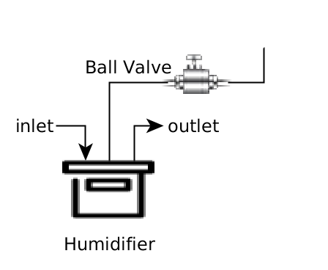

**Iteration 3:**

* Comparison with Pumani and experiments on rebreathing of CO2 in Open bubble CPAP.
* Humidifier water filling mechanism with ball valve.
* Load testing with the new humidifier setup, continuous run for more than 8 hours
* Comparison between looped vs unidirectional (separate inspiratory & expiratory limb) nasal prongs usage.

**Iteration 4:** 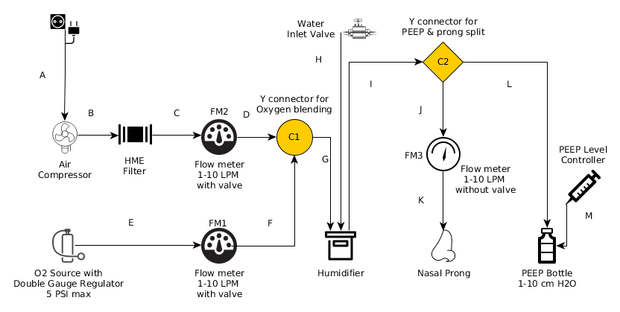

* Humidifier selection revised. Medical grade commonly available bottle shaped humidifiers.
* Alternate silicone tubing for the breathing circuit. (ID-8mm, OD-12 mm)

It has advantage of compatibility with a wide range of tube connectors.

* Oxygen blending feature addition in CPAP.
* 3-Flow-Meter method in contrast with existing pumani 2 FM design.
* Oxygen cylinder valve comparison and operating pressure levels selection.